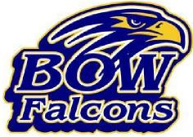 | 2025 Mini Golf Registration  Bow Falcons Booster Club Golf Tournament  Saturday, September 20th  Chucksters, Hooksett, NH  Registration starts at 9:30 am  Shot-gun start at 10:00 am  Golf and ice cream included

($25/person) Teams of 4, 5 or 6. Any golfers under 12 must have an adult on their team
Team Name:
Golfer #1 (Team Captain/Official Score Keeper)Name: | Golfer #1 E-mail & Contact # | Golfer #2 Name
Golfer #2 Email & Contact # | Golfer #3 Name | Golfer #3 Email & Contact #
Golfer #4 Name | Golfer #4 E-mail & Contact # | Golfer #5 Name
Golfer #5 Email & Contact # | Golfer #6 Name | Golfer #6 Email & Contact #

NOTE: Partial teams will be grouped at tournament.
If paying on-line:
Complete payment on our website and email this completed form to bowfalconbooster@gmail.com
If mailing payment:
Please complete this form
Make checks payable to the Bow Falcons Booster Club
Mailing address: Kristen Burgess 12 Rand Road, Bow NH 03304

